BroadVision Java Roadmap

Summary

This summary gives the high-level roadmap for BroadVision’s use of Java technology. It summarizes how Java can be used together with BroadVision’s One-To-One Application system now and in the future.

Some background concepts first:

- Java is a full-featured, modern object-oriented programming language used for application development.
- Javascript is a high-level scripting language .
- Java Beans are a model for Java components (objects that can be dropped into a system and executed).
- Enterprise Java Beans (EJBs) are a standard environment for executing Java Beans in a distributed system., much like a java based transaction monitor.

Java and JavaScript in V4.0/V4.1

- JavaScript is used as the server-side scripting language for customizing One-To-One applications.
- The (server-side javascript) scripts call into lightweight components, which are implemented in C++.
- The lightweight components can call through the One-To-One API to BroadVision’s system components (e.g., profile manager) which are accessed remotely using CORBA.
- Java can be used to extend the system by using new system components. Three ways of doing this include:
- Calling out to standalone Java applications.
- Calling new Corba servers implemented in Java.
- Invoking Enterprise Java Beans that are running an EJB server that supports IIOP.

Enhanced Java support in V4.2
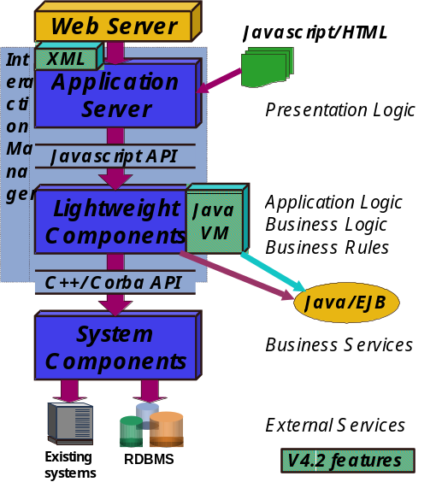
Figure 1 – V4.2 Architecture with Java
- In V4.2, BroadVision will embed a Java Virtual Machine within the Interaction Manager. This will allow the lightweight components to be implemented in either Java or C++.
- Java components will be able to access the same API’s and data as C++ components.
- Javascript will still be used as the server-side scripting language.
- BroadVision components will still be implemented in C++.
- One-To-One can still call out to Java applications, Java Corba servers, or EJBs.
- V4.0/4.1 applications will continue to work with minimal impact.
- Applications which still use the V3.0 Dynamic Object/Template model will continue to run in the same fashion as under 4.0.

Figure 1 shows the 4.2 architecture of One-To-One.

Support for Enterprise Java Beans

- In Version 5.0, BroadVision will develop an EJB interface to the One-To-One system.
- Javascript will continue to be used as the scripting language for customizing the look and feel of the application. Java Server Pages executed by the EJB Server will also be supported.
- Java (and EJBs) will be the preferred mechanism for extending the system with new lightweight components.
- BroadVision will ship components implemented in Java as Enterprise Java Beans.
- V4.2 programs, including ones with custom C++ components, will run with minimal impact.
- One-To-One applications can still call out to Java applications, Java Corba servers, or EJBs. External Corba servers can also be implemented in C++.
- BroadVision System components will continue to be implemented as external servers using Corba and C++ or Java.
- The V3.0 dynamic Object and Template model will no longer be supported.

Figure 2 shows the high level architecture using EJBs. Note that applications can run either using Javascript as the scripting language (which BroadVision will follow for its products) or using Java Server Pages (which will be an option for customers developing applications from scratch).

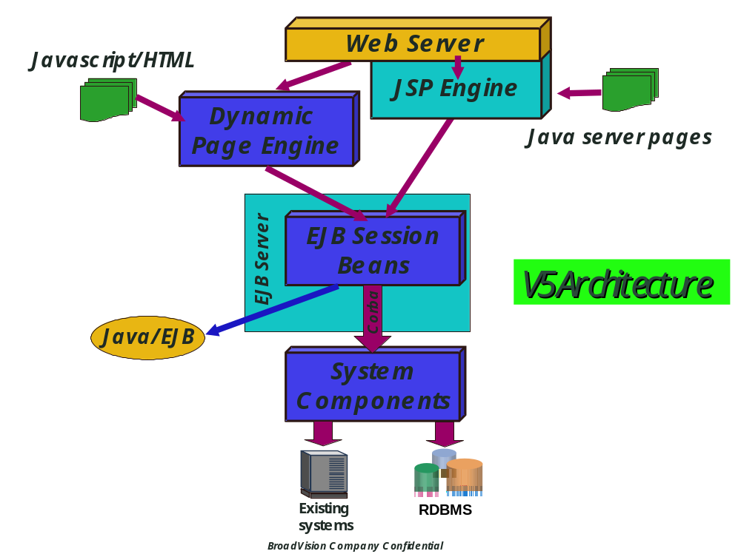

Figure 2 – BroadVision EJB Architecture

